| Google Classroom | Version: <1.0> |
| --- | --- |
| Use-case-Realization Specification: Complete Assignment | Date: <05/Dec/21> |
| <document identifier> | |

Revision History

| **Date** | **Version** | **Description** | **Author** |
| --- | --- | --- | --- |
| <05/Dec/21> | <1.0> | <Initial version> | Bui Hoang Quan |
| <08/Dec/21> | <1.1> | <Edited version> | Bui Hoang Quan |
|  |  |  |  |
|  |  |  |  |

**Google Classroom**

**Online Learning Platform**

**Use-Case Specification: <Create Classwork>**

**Version 1.1**

# Manage Profile

## Brief Description:

* This use-case allows users to create assignments, questions, materials, add a topic, reuse posts, view the assignment work as well as refer to the time table and the class resources on google drive.
* Subject: Teachers
* Purpose: Make it easier to assign or manage teachers' assignments.

# Flow of Events

## Basic Flow

* User click on the 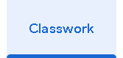button on the main page at the middle top corner, then the page will be changed to the function page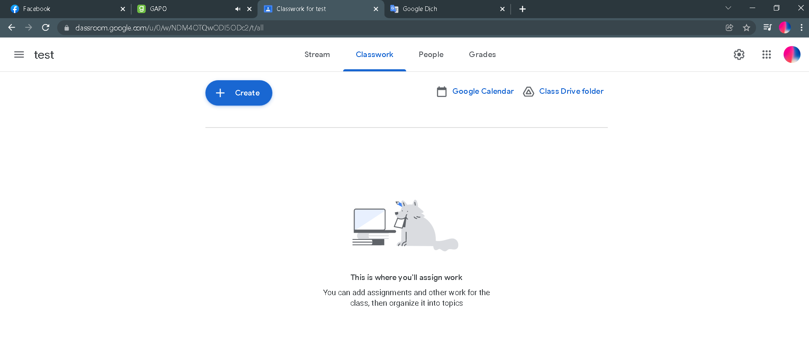 due to the Classwork’ s functions.
* The system will show the functions like Create on the left side of the page which is the blue button with a “+” symbol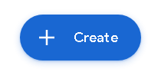, the Google Calendar button is on the right side of the page and next to it is the Class Drive folder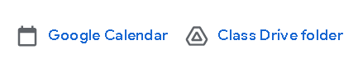. All the buttons will have slight shadow effects when we use mouse hover on them.
* User now can start to using the function of the page:

1. Create: Click on the blue Create button on the left side of the page to view all the options: Assignment, Quiz Assignment, Question, Material, Reuse Post, Topic. 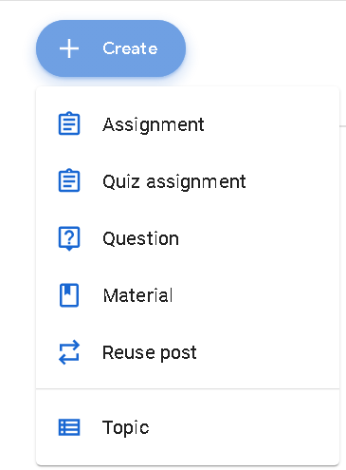
2. Assignment, Quiz Assignment: After clicking on the “Assignment” or “Quiz Assignment” option, a new screen will appear and cover all the previous screen. On the left side, we will have a title bar uses to write down the title of the assignment, right below of that we have instruction bar to fill in the guidelines of the assignment and it’s optional, we also have some simple effect to add in our instructions like bold, italic, underlined, bulleted list and remove formatting. Right below it is the attach bar to upload the resource for the assignment which includes Google Drive, file from computer, link, YouTube video, a “+” symbol with options of Docs, Slides, Sheets, Drawings, Forms when clicked on it. On the right hand side we have another option bar to edit our information about the assignment. “For” option is to make sure the assignment is delivered to the right class or student subjects, “Point” option is to change the grade scale of the class, “Due” option will set a deadline for submission by clicking on it and choose the date in the calendar, right below is the “Topic” option, when user click on it, the 2 more options will appear, “No topic” and “Create topic”, click on “Create topic” will appear a screen to let you fill in the name of the topic for the assignment. Last but not least is the Rubric section where teachers can have their own self-assessment. 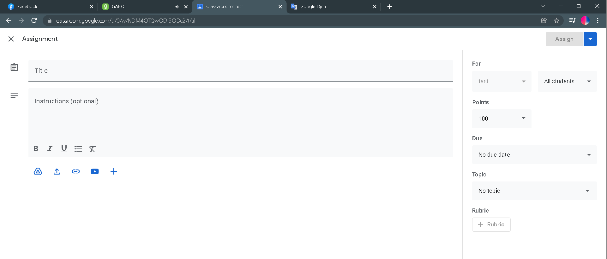
3. Question: After clicking on the “Question” option, it will basically appear on the same screen as the “Assignment” and “Quiz Assignment” one. The only difference is that there is no Rubric section this time and 2 check boxes “Students can reply to each other” and “Students can edit answer”, the first checkboxes allow students can comment on other students work and the second one allows students to edit their answer. 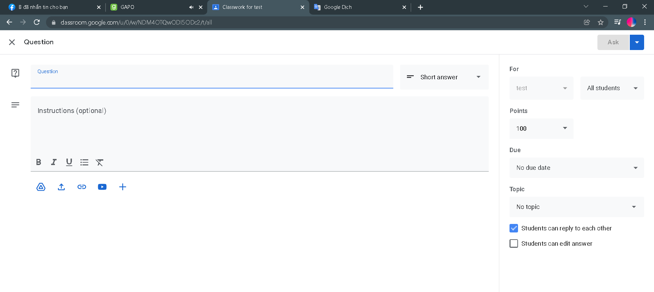
4. Material: The same screen as previous options (“Question” option) will appear when teachers click on the “Material” option and the only difference is that the 2 checkboxes no longer exist. 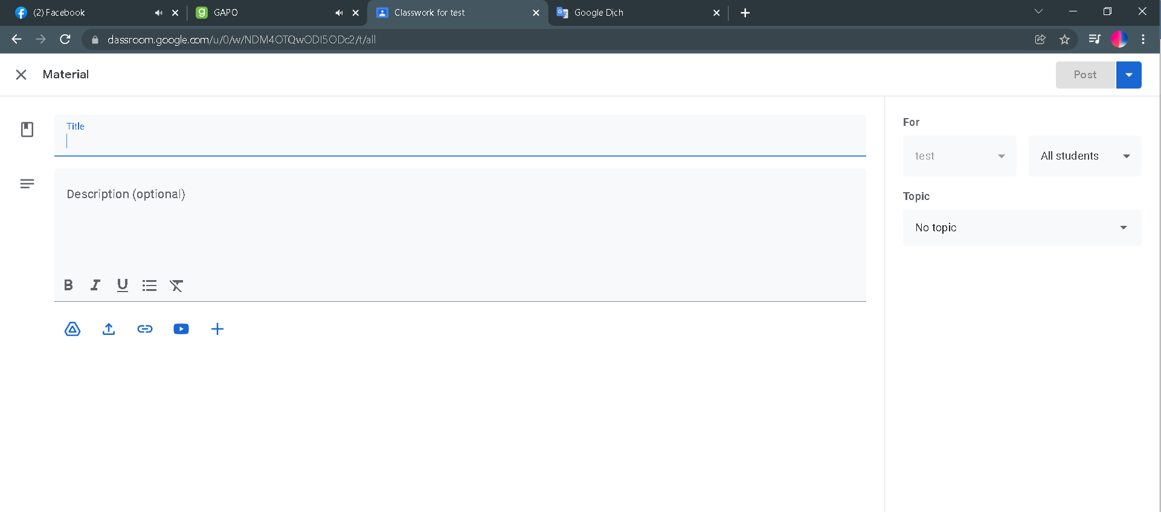
5. Reuse post: An option allows the teacher to use the same post and deliver to any class that the teacher is managing. A small box will appear and say “Select class” at the title bar, down below, all the classes that the teacher are managing will be listed and the teachers can easily choose the class the he/she wants to reuse the post, the class that the teacher hovered by mouse will have a slight shadow effect. After clicked on the class, another box will appear with the title “Select post (class that he/she chose)”, below is the list of the posts of the selected class and then the teacher can chose any post, if there is no post, a message shows up and says “The selected class has no post”, below we have a check box “Create new copies of all attachments” to create copy of attachments and on the right hand side is the “Reuse” button which is the button we will click on when we finishing choosing our post. At the top corner on the right side we also have a cancel button which is represented by “X” symbol. 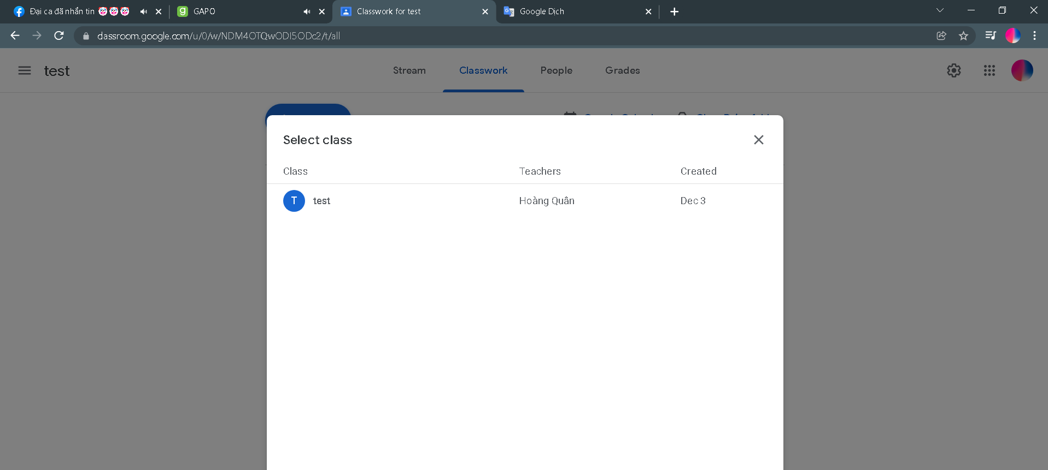
6. Topic: An Add topic panel appears and the topic name can be filled in in the topic bar, down below is the Cancel button and Add button to cancel the panel or add new topic to the class work. If the teacher clicks on Add, a new topic named before will appear in the main screen and students will see this topic once work is added to it. On the left side of the topic is the  button, hover it will have a slight shadow effect, click on it will appear some options: rename,, delete, copy link, move up and move down the topic.

